TOPIC 3 : DIVIDE AND CONQUER
NAME: LAKSHMI DEVI. J
REG. NO: 192524300
1. Write a Program to find both the maximum and minimum values in the array. Implement using any programming language of your choice. Execute your code and provide the maximum and minimum values found.

Aim
To find the minimum and maximum values in an unsorted array.
Pseudo Code
- Read the array.
- Set the first element as both minimum and maximum.
- Traverse the remaining elements.
- Update minimum if a smaller element is found.
- Update maximum if a larger element is found.
- Print minimum and maximum.
Python Program
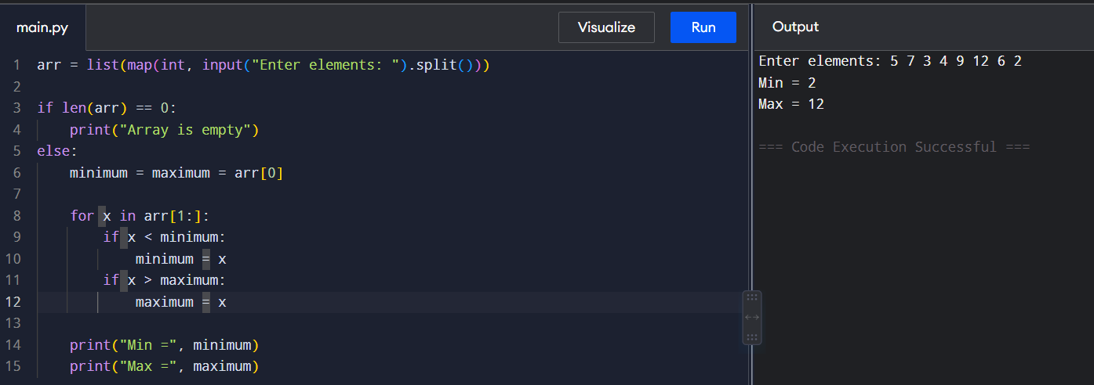
Time Complexity: O(n)
Space Complexity: O(1)
2. Consider an array of integers sorted in ascending order: 2,4,6,8,10,12,14,18. Write a Program to find both the maximum and minimum values in the array. Implement using any programming language of your choice. Execute your code and provide the maximum and minimum values found.

Aim
To find the minimum and maximum values in an array sorted in ascending order.
Pseudo Code
- Read the sorted array.
- The first element is the minimum.
- The last element is the maximum.
- Print both values.
Python Program
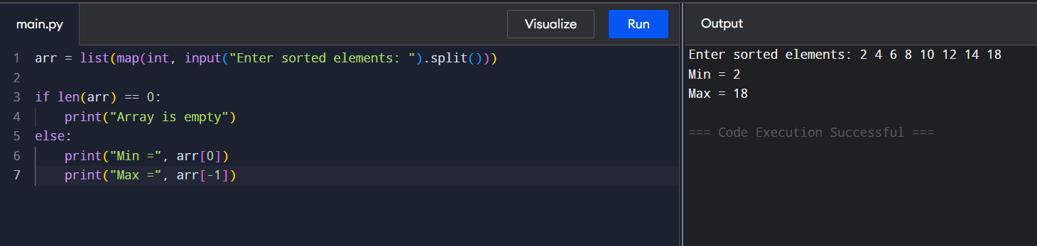

Time Complexity: O(1)
Space Complexity: O(1)

3. You are given an unsorted array 31,23,35,27,11,21,15,28. Write a program for Merge Sort and implement using any programming language of your choice.

Aim
To sort an unsorted array using the Merge Sort algorithm.
Pseudo Code
- Divide the array into two halves.
- Recursively sort both halves.
- Merge the two sorted halves.
- Continue until the complete array is sorted.
- Print the sorted array.
Python Program
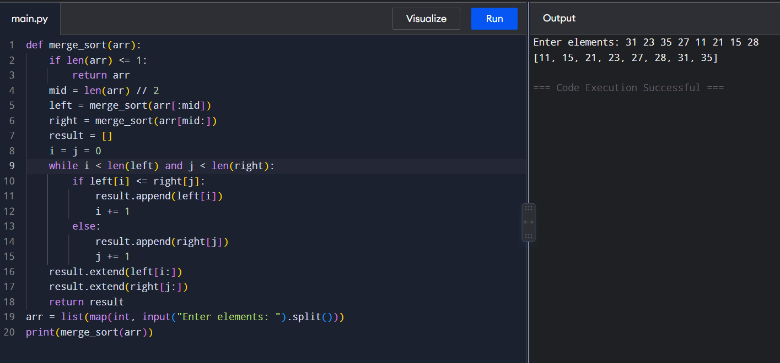

Time Complexity: O(n log n)
Space Complexity: O(n)

4. Implement the Merge Sort algorithm in a programming language of your choice and test it on the array 12,4,78,23,45,67,89,1. Modify your implementation to count the number of comparisons made during the sorting process. Print this count along with the sorted array.
Aim
To implement Merge Sort and count the number of comparisons performed during sorting.
Pseudo Code
- Divide the array into two halves.
- Recursively sort both halves.
- During merging, increment the comparison counter whenever two elements are compared.
- Merge the elements.
- Print the sorted array and comparison count.
Python Program
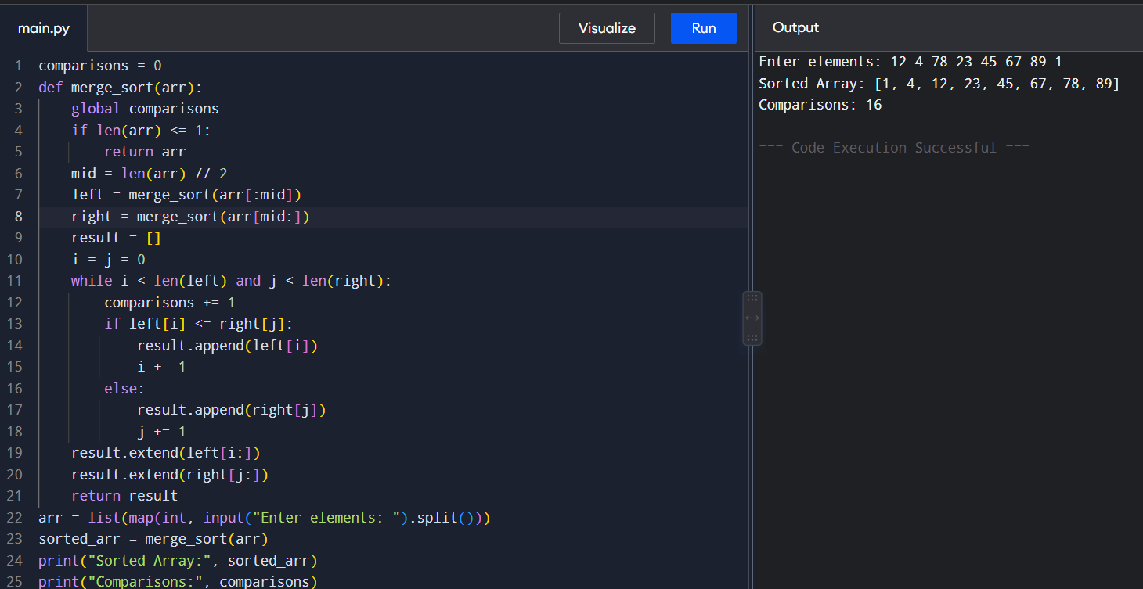
Time Complexity: O(n log n)
Space Complexity: O(n)
5. Given an unsorted array 10,16,8,12,15,6,3,9,5 Write a program to perform Quick Sort. Choose the first element as the pivot and partition the array accordingly. Show the array after this partition. Recursively apply Quick Sort on the sub-arrays formed. Display the array after each recursive call until the entire array is sorted.

Aim
To sort an array using Quick Sort by selecting the first element as the pivot and display the array after each partition.
Pseudo Code
- Select the first element as pivot.
- Partition the array into elements smaller and larger than pivot.
- Place pivot in its correct position.
- Recursively apply Quick Sort to the left and right parts.
- Print the array after each partition.
Python Program
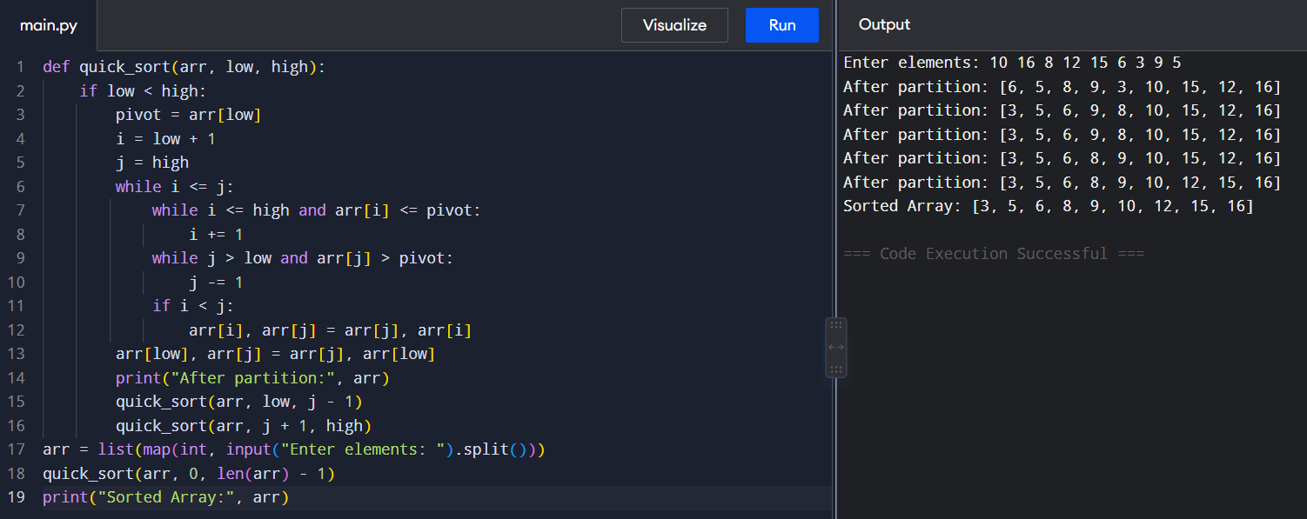
Time Complexity: O(n log n)
Space Complexity: O(log n)

6. Implement the Quick Sort algorithm in a programming language of your choice and test it on the array 19,72,35,46,58,91,22,31. Choose the middle element as the pivot and partition the array accordingly. Show the array after this partition. Recursively apply Quick Sort on the sub-arrays formed. Display the array after each recursive call until the entire array is sorted. Execute your code and show the sorted array.

Aim
To implement Quick Sort using the middle element as the pivot.
Pseudo Code
- Select the middle element as pivot.
- Move elements smaller than pivot to the left.
- Move elements greater than pivot to the right.
- Recursively sort both parts.
- Display the array after each partition.
- Print the sorted array.
Python Program
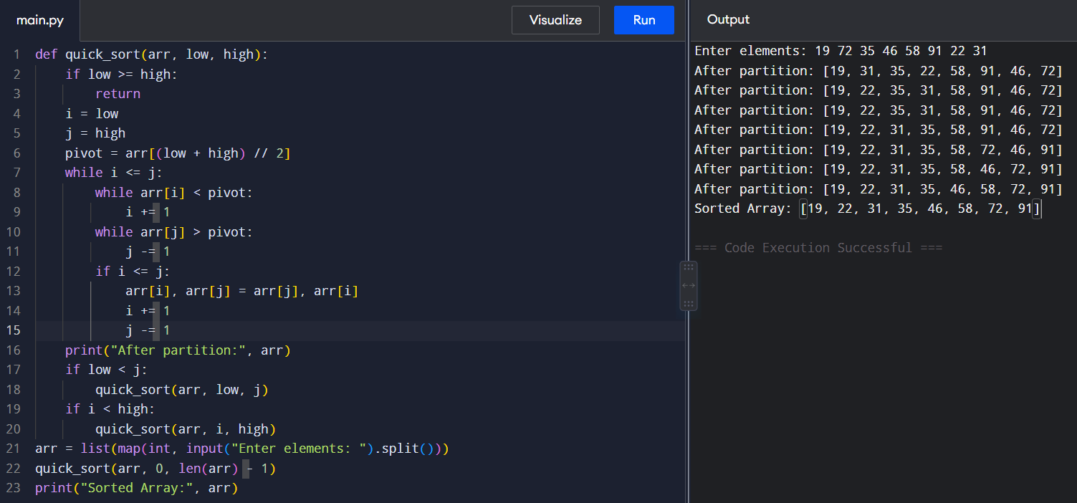
Time Complexity: O(n log n)
Space Complexity: O(log n)
7. Implement the Binary Search algorithm in a programming language of your choice and test it on the array 5,10,15,20,25,30,35,40,45 to find the position of the element 20. Execute your code and provide the index of the element 20. Modify your implementation to count the number of comparisons made during the search process. Print this count along with the result.
Aim
To find an element in a sorted array using Binary Search and count the number of comparisons.
Pseudo Code
- Set low = 0 and high = n-1.
- Find the middle element.
- Compare it with the search key.
- If equal, return its index.
- If key is smaller, search the left half.
- Otherwise search the right half.
- Repeat until the element is found or the range becomes empty.
Python Program
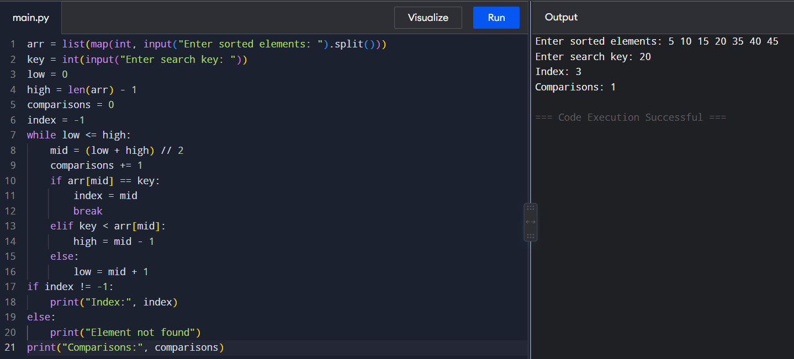
Time Complexity: O(log n)
Space Complexity: O(1)
8. You are given a sorted array 3,9,14,19,25,31,42,47,53 and asked to find the position of the element 31 using Binary Search. Show the mid-point calculations and the steps involved in finding the element. Display, what would happen if the array was not sorted, how would this impact the performance and correctness of the Binary Search algorithm?
Aim
To find an element in a sorted array using Binary Search and display the midpoint calculations.
Pseudo Code
- Set low = 0, high = n-1.
- Calculate mid = (low + high) // 2.
- Compare arr[mid] with the key.
- If equal, return the position.
- If key is greater, move to the right half.
- Otherwise move to the left half.
- Repeat until found.
Python Program
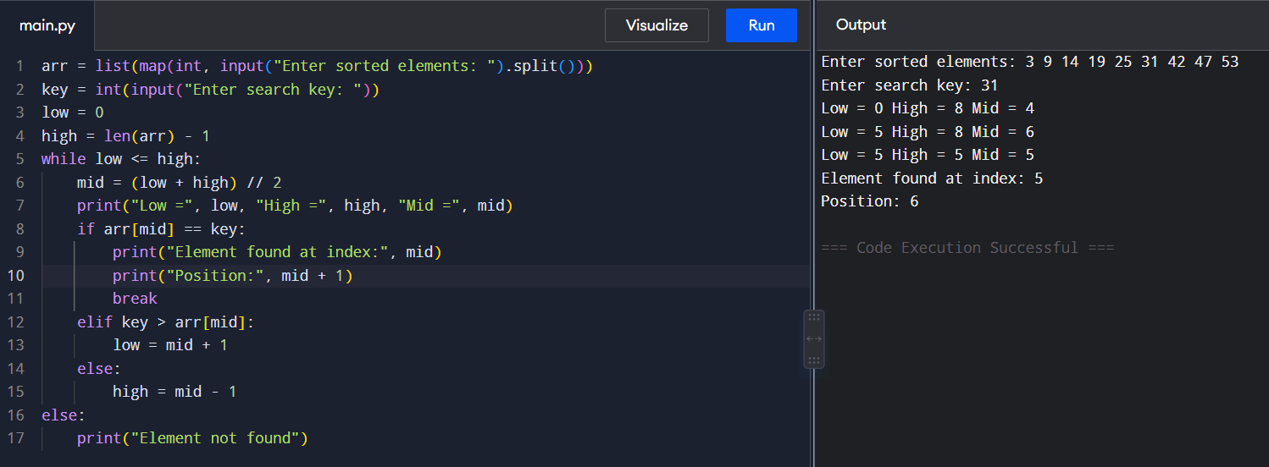
Time Complexity: O(log n)
Space Complexity: O(1)
9. Given an array of points where points[i] = [xi, yi] represents a point on the X-Y plane and an integer k, return the k closest points to the origin (0, 0).
Aim
To find the k points closest to the origin (0,0) using their Euclidean distance.
Pseudo Code
- Read the points and k.
- Calculate squared distance x² + y² for every point.
- Sort the points according to distance.
- Select the first k points.
- Print the result.
Python Program
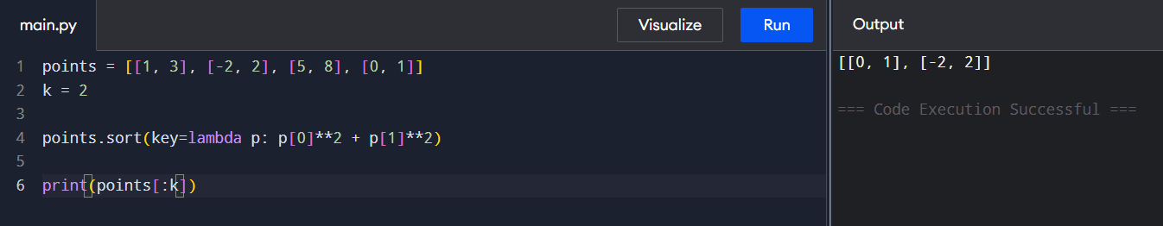
Time Complexity: O(n log n)
Space Complexity: O(n)
10. Given four lists A, B, C, D of integer values,Write a program to compute how many tuples n(i, j, k, l) there are such that A[i] + B[j] + C[k] + D[l] is zero.
Aim
To count the number of tuples (i,j,k,l) such that A[i] + B[j] + C[k] + D[l] = 0.
Pseudo Code
- Calculate all sums of elements from A and B.
- Store their frequencies in a dictionary.
- Calculate all sums of elements from C and D.
- For each sum, check whether its negative exists in the dictionary.
- Add the corresponding frequency to the answer.
- Print the count.
Python Program
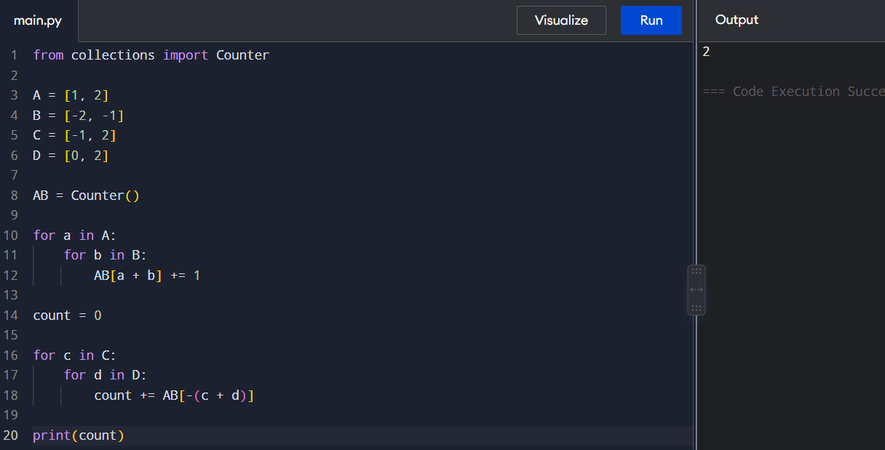
Time Complexity: O(n²)
Space Complexity: O(n²)

11. To Implement the Median of Medians algorithm ensures that you handle the worst-case time complexity efficiently while finding the k-the smallest element in an unsorted array.
Aim
To find the kth smallest element in an unsorted array using the Median of Medians algorithm.
Pseudo Code
- Divide the array into groups of five.
- Find the median of each group.
- Recursively find the median of these medians.
- Use it as the pivot.
- Partition the array into smaller, equal and larger elements.
- Recursively search the required part.
- Return the kth smallest element.
Python Program
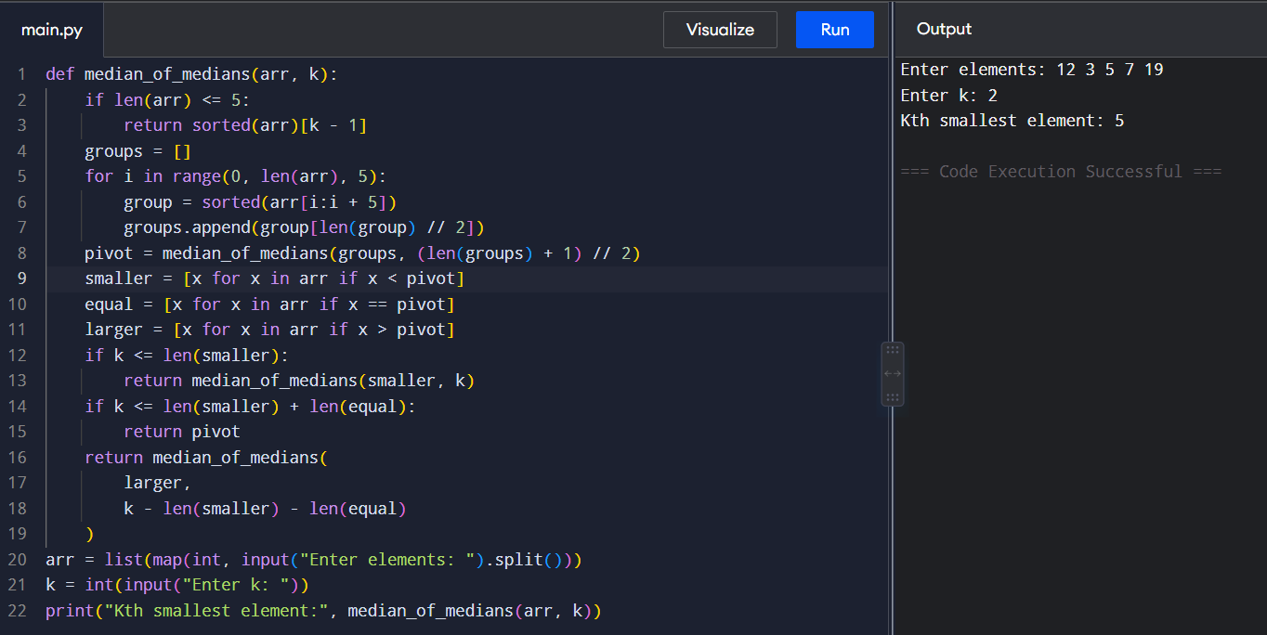
Time Complexity: O(n)
Space Complexity: O(n)
12. To Implement a function median_of_medians(arr, k) that takes an unsorted array arr and an integer k, and returns the k-th smallest element in the array.
Aim
To implement a reusable median_of_medians(arr, k) function to find the kth smallest element.
Pseudo Code
- Divide the array into groups of five.
- Find the median of every group.
- Find the median of the medians.
- Use it as a pivot.
- Partition the array.
- Recursively search the required partition.
- Return the kth smallest element.
Python Program
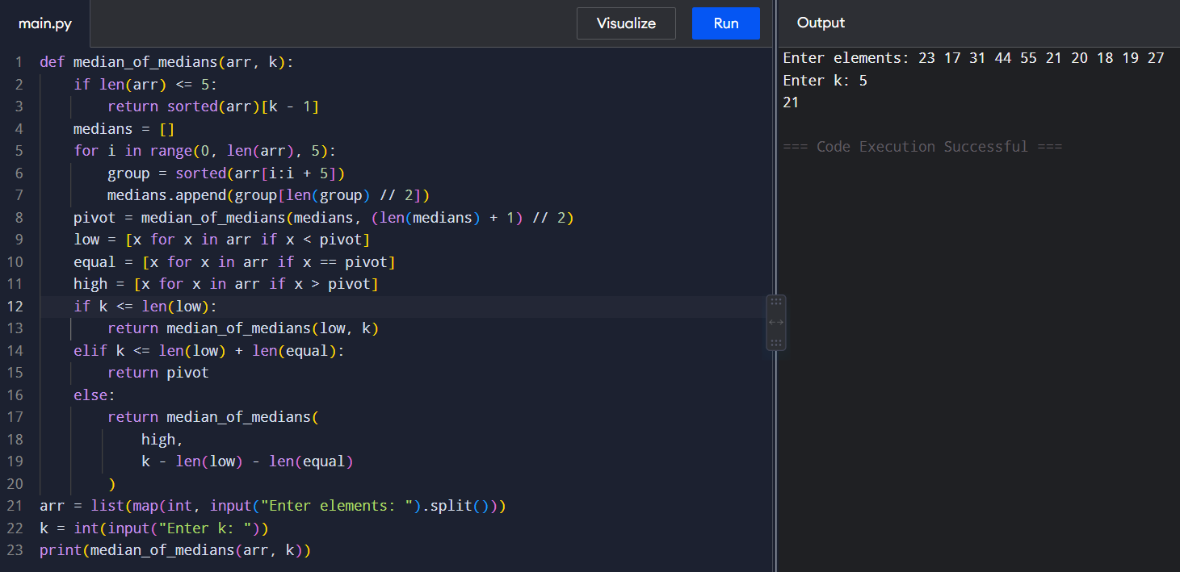
Time Complexity: O(n)
Space Complexity: O(n)
13. Write a program to implement Meet in the Middle Technique. Given an array of integers and a target sum, find the subset whose sum is closest to the target. You will use the Meet in the Middle technique to efficiently find this subset.
Aim
To find a subset whose sum is closest to a given target using the Meet in the Middle technique.
Pseudo Code
- Divide the array into two halves.
- Generate all subset sums of both halves.
- Combine sums from the two halves.
- Find the sum closest to the target.
- Print the closest subset and its sum.
Python Program
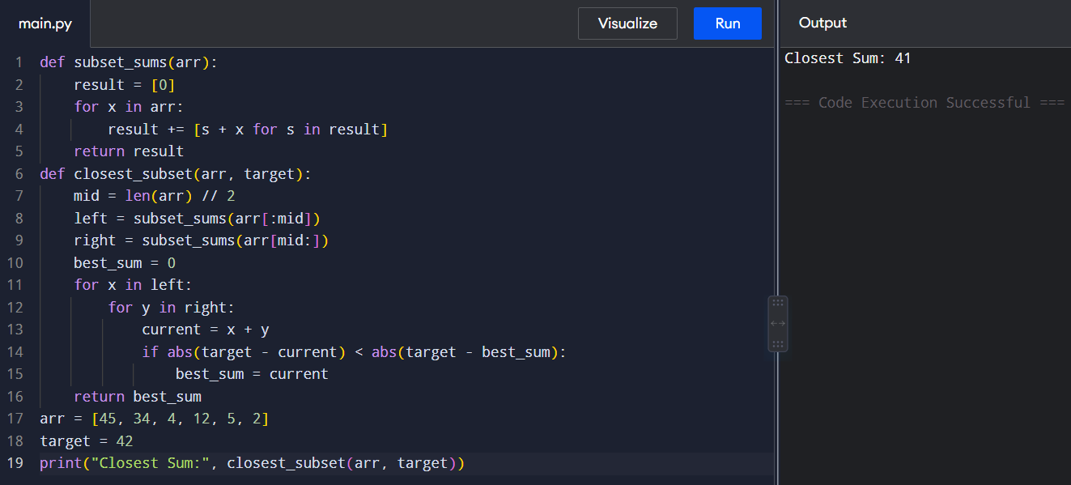
Time Complexity: O(2^{(n/2)} × 2^{(n/2)})
Space Complexity: O(2^{(n/2)})
14. Write a program to implement Meet in the Middle Technique. Given a large array of integers and an exact sum E, determine if there is any subset that sums exactly to E. Utilize the Meet in the Middle technique to handle the potentially large size of the array. Return true if there is a subset that sums exactly to E, otherwise return false.
Aim
To determine whether a subset exists whose sum is exactly equal to the given target using Meet in the Middle.
Pseudo Code
- Divide the array into two halves.
- Generate all subset sums of the first half.
- Generate all subset sums of the second half.
- For every first-half sum, check whether target - sum exists in the second-half sums.
- If found, return True.
- Otherwise return False.
Python Program
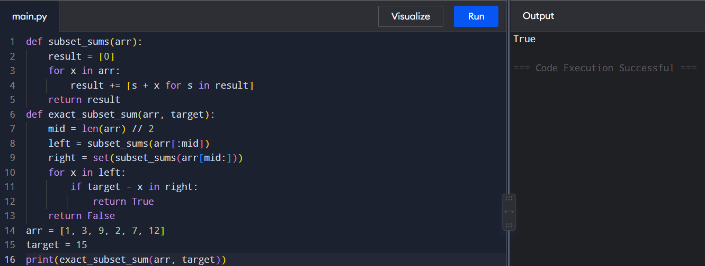
Time Complexity: O(2^(n/2))
Space Complexity: O(2^(n/2))

15 Given two 2×2 Matrices A and B
A=(1 7 3 5) B=( 1 3 7 5)
Use Strassen's matrix multiplication algorithm to compute the product matrix C such that C=A×B.

Aim
To multiply two 2×2 matrices using Strassen's Matrix Multiplication algorithm.
Pseudo Code
- Divide matrices into four elements.
- Calculate seven Strassen products:
  - M1 = (A+D)(E+H)
  - M2 = (C+D)E
  - M3 = A(F-H)
  - M4 = D(G-E)
  - M5 = (A+B)H
  - M6 = (C-A)(E+F)
  - M7 = (B-D)(G+H)
- Calculate:
  - C11 = M1 + M4 - M5 + M7
  - C12 = M3 + M5
  - C21 = M2 + M4
  - C22 = M1 - M2 + M3 + M6
- Print the product matrix.
Python Program
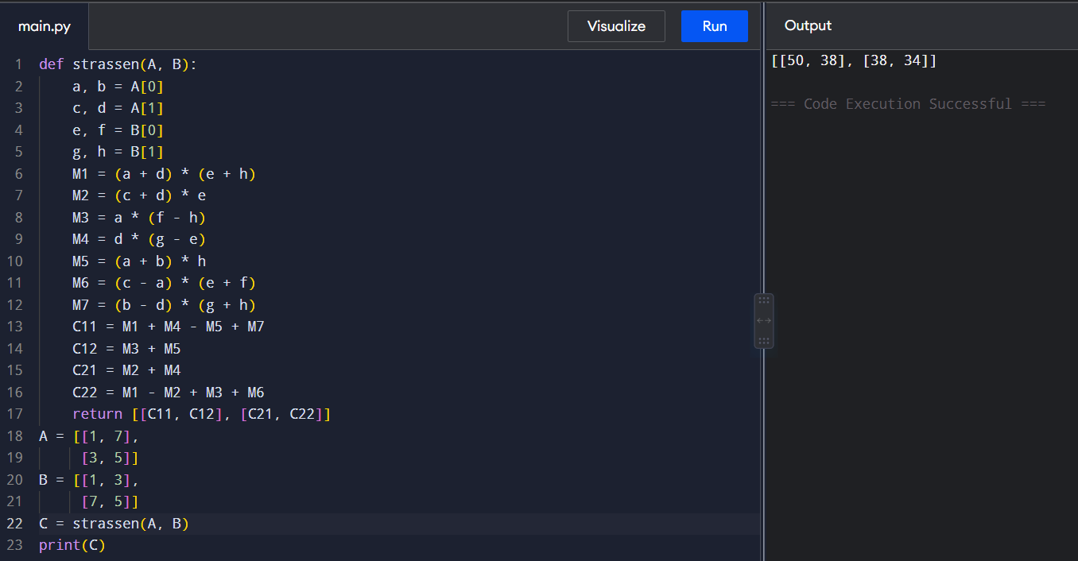
Time Complexity: O(n^{log₂7}) ≈ O(n^{2.807})
Space Complexity: O(n²)
16. Given two integers X=1234 and Y=5678: Use the Karatsuba algorithm to compute the product Z=X x Y
Aim
To multiply two large integers using the Karatsuba multiplication algorithm.
Pseudo Code
- If either number has one digit, multiply directly.
- Find the number of digits and divide both numbers into two halves.
- Calculate:
  - z0 = ac
  - z1 = (a+b)(c+d) - z0 - z2
  - z2 = bd
- Combine the results:
result = z2 × 10^(2m) + z1 × 10^m + z0
- Print the product.
Python Program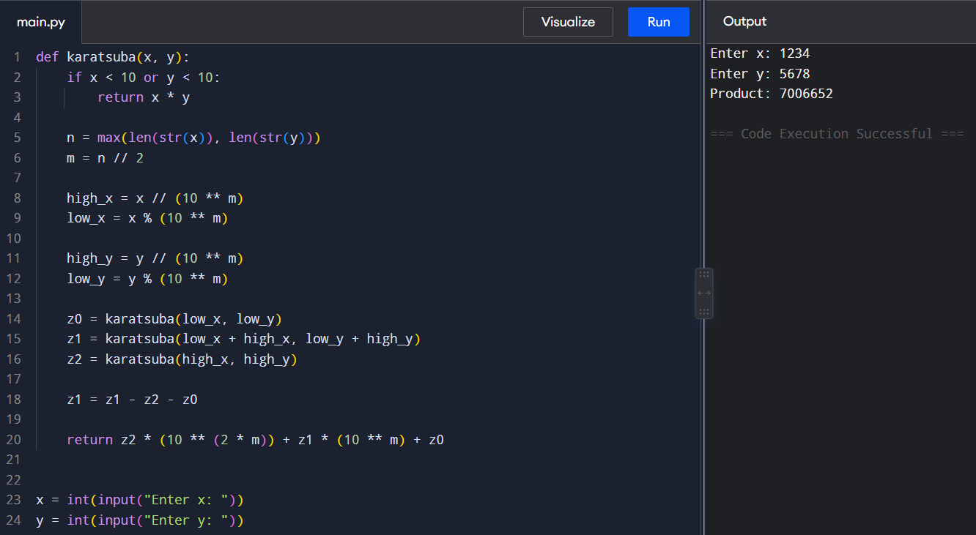
Time Complexity: O(n^{log₂3}) ≈ O(n^{1.585})
Space Complexity: O(n)

